**Simple Embedded System Mobile Phone**

A mobile phone is a wireless handheld device that allows users to make and receive calls. While the earliest generation of mobile phones could only make and receive calls, today’s mobile phones do a lot more, accommodating web browsers, games, cameras, video players and navigational systems.

Simple Embedded Block Diagram

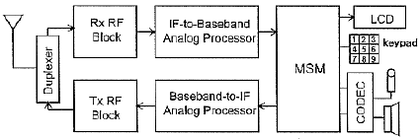

Mid Complex Embedded Block diagram

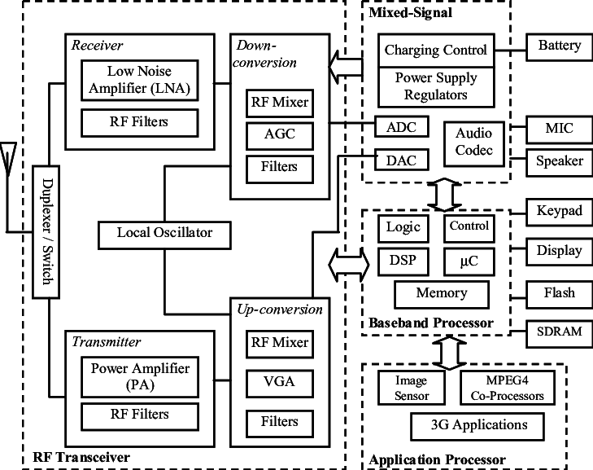

High Level Requirements

* Calling
* Receiving the calls
* Sending Text messages
* Receiving text messages
* Internet browsing
* SD Card
* Sound and Music Enablement
* Camera
* Storage for pictures

Low Level Requirement

* Keypad
* Dialing a number
* Green button for dialing and receiving the calls
* Red button for rejecting a call
* Letters associated with numbered buttons for text messages
* Slots for Sim Card and SD cards